

Posted on [October 8, 2017](http://www.voxspace.in/2017/10/08/voxspace-exclusive-torrents/) by [VOX THEFOX](http://www.voxspace.in/author/voxthefox/)

**Editor’s Note**

Every six hours 6780 Movies are ripped and uploaded in Torrent sites within the IP Addresses basing in India. The most used torrent sites by Netizens within the country are Mononova, ThePirateBay, KickAssTorrents and ISOHunt. India is only behind the US in accessing these websites and downloading material from them. However, India has the largest user base for a widely known Torrent aggregator website called Torrentz. Within all these websites, there is, however, one website, which in the past 8 years, has had a traffic attraction of more than any other website based out of India. The site in question was started in a shed in Nungambakkam and was initially named simply as MoviesFreeTo. Within 3 weeks the name was changed to something simple and locally relevant to remember. Tamil Rockers. This article is the story of Tamil Rockers, and takes a neutral dive in, into the world of Piracy in terms of Online Piracy, Movie Business and the mechanism involved, and Social Media propagation. After months of requesting and communicating, we finally got in contact with Bhaskar Kumar, who plays an integral part in the foundation and propagation of Tamil Rockers. Our conversations with him come below, and they are the views of the person involved. Our web platform does not claim to stand by or comment upon the happenings stated in this article.

**Online Piracy Is A Criminal Offence Under Sec 63, 63-A, 65 and 65-A of the Copyright Act, 1957 which prescribes imprisonment for 3 years and also fine of up to Rs 3 lakh.**

A few statistical data and aspects have been confirmed and conducted from the inputs of research done by Envisioned And Motion Pictures study of Movie Piracy within India, documented under the publication, India: Internet Piracy Landscape Audit.

**Chapter One – Saravanampatty, Coimbatore, 2003 – The Master Print**

17-year-old Bhaskar Kumar walks into his small cubicle of a shop. Practically a man-sized wooden box, in the midst of the ten other retail shops, in the bustling bazaar at Saravanmpatty. All the shops are in the business of Digital media works. A fancy little name for DTP and Xerox machines whirring in these cubicle shops all through the day. Students, Job enthusiast flock this bazaar from early in the morning to late in the night, buying sundries in relation to their needs. Highest sales, of course, were course materials from particular colleges, Xerox copies of notebooks of a nerdy topper, or in a recent phenomenon CDs. While we are on the subject of CDs, the bazaar in question is infamous for selling practically every software out in the world web market, in the form of ‘cracked’ software. Starting from the just launched Windows OS, to Photoshop, to Nero CD Burner, to basically everything. And this is not taking into account the humongous business that the shops started making while selling PC Games. One such outlet for Video Games and Movie CD’s is what Bhaskar Kumar, turns his key into and opens his cardboard of a door, is for. “Shiny Videos and CD’s” is the name of this humble little establishment, which is locally known as “Corner CD Shop”. Corner because it was situated in the corner of the plethora of digital shops. A little trackback on this establishment tells us that Bhaskar, a couple of years back, flunks his 10th standard. He is practically hopeless about his future, as even his supplementary exams show him the same result. In desperation comes hope, and in hopelessness comes brilliance sometimes, isn’t it? And so, Bhaskar stumbles upon this idea to start a CD rental shop in the Bazaar.

He opens the shop, and within a few moments a young group of four friends, with their school bags on, appear at the shop. They explore the CD’s collection standing tall in wooden shelves behind Bhaskar, who is just sitting on a stool looking at these young students. They discuss, banter, giggle and finally zero in on “Terminator 3: Rise Of Machines”.

“Rent for 30 per day. Buying 200” Bhaskar says as a matter of factly

“How is the print, Anna? And the movie?”

“Master Print Only. Movie average. Matrix is Better” Bhaskar says, sounding as a master film critic. Every shop owner needs to sound like he knows everything about everything, yes? Also, He knows that in a group, when you put another option, there are chances that they’ll take two, to satisfy anyone and silence any conflict. And as expected the talks start again within the group.

“Matrix Revolutions is good, Anna?” asks someone breaking out from the pitching up discussion.

“Yes. Story-wise it is good. And fights also. Terminator graphics and Arnold is nice” Bhaskar says, knowing very well, that a little more emphasis on the word ‘graphics’ will make them not just rent the CD but buy both of them. One thing he has learnt from his experience of running this shop for the past four months is that the youth visiting him, are suckers for graphics and fights. Those are the keywords.

And thus, the group buys two CDs. And his first sale for the day is a cool 400. Thus, his shop makes good business in the day selling to boys salivating on mindless action, James Bond, Terminators, Graphics, and such. His evenings are more interesting when he gets interacting with Young adults, who come in for some very particular movies, which presumably have some *content* (read sex scenes and Sharon Stone for most parts). “Shiny Video and CD’s” thrives in the night, when a different *stock* of movies fills up the lower rack, and a sheet of paper comes out to the table.

Men and Teens (aspiring to be Men overnight) frequent the shop, and Bhaskar shows them the sheet, filled with details of Porn Movies. And there’s no rental for them, only buying. Each Porn Movie, stored in 2 CD’s pack, is sold for a cool 350 rupees. When Bhaskar runs out of the stock, he makes his weekly trip to Chennai, to buy the stockpiles from his friend, Daniel Raju, at Majestic Circle.

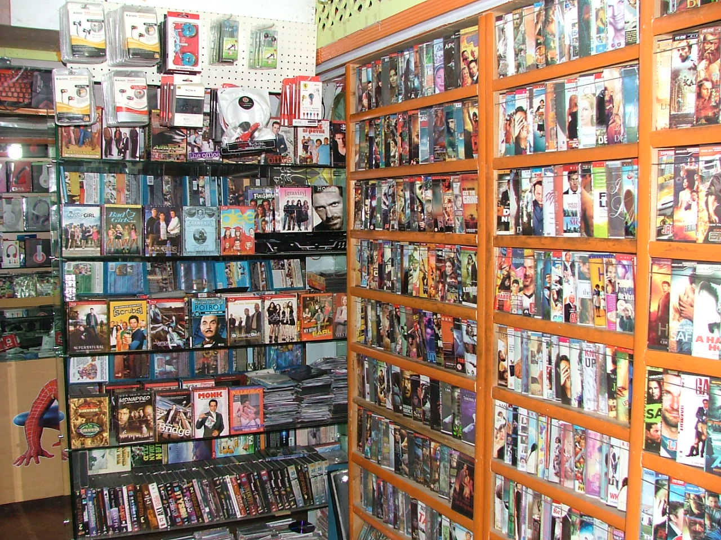

**Chapter Two – Vetrivel Theatre, Chennai 2003 – The Broker’s Report**

The first day is always crucial. It makes or breaks a movie. That much everyone knew. But what very few people knew was a street fact that, it wasn’t the first day that decided the fate of a film. Neither the weekend following. It was the six hours before the release of the film that decided the fate. Producers and Distributors six hours before the first show would indulge in the last bid, to offer slots and extensions. Usually, the whole arrangement would be taken care by mediators, one of them being Daniel Raju, who would collect Paper folding’s *‘Chits’* from each distributor in the city, travelling from one corner of the city to the another, in his old Chetak scooter. These Chits would contain the amount, the distributor was willing to spend to acquire the movie for more number of shows beyond the first day. How did he decide how much he wants to spend if at all he does?

It’s a simple logic, the distributors are shown the movie only up to the first half, ten hours before the actual release. The second half is never shown, to protect the secrecy of the plot. Then the producers would go back to their places, and decide on a gamble to invest in the movie beforehand. It was a risky gamble. If the movie clicked, the producer would coolly double his *Ask* rate. If it flunked, the investment is gone. To ensure that there is a common guarantee between the Producers and the distributors, irrespective of the movie performance and fluctuation, a third neutral unofficial body was formed in the late 70’s called The Brokers. They took care of the bidding procedure, guaranteed Asks, and ensured that everything was proper. In early 90’s cities like Hyderabad, Chennai, Bangalore and other major south Indian cities, had more than 150 broker agencies, each employing more than two hundred people each.

Although the business of movie piracy, facilitated by these brokers over time, is a vast discussion, our narrative requires a small peek into Daniel Raju’s work. Daniel Raju, much like his friend in Coimbatore, was a man of humble academic bearings. But what he did excel was in building contacts. He started being a Broker, interacting with Producers and Distributors directly at the age of fifteen. Thereafter, he started his own Brokering business, by getting really good deals for smaller budget films. He had a knack of getting them two-week slot bookings and had made a name for himself with emerging production houses. By the time he touched twenty, he knew the potential of Movie piracy as a business. And it was a time when Video CD’s were just coming out. Initially, he tied up with Internet Cafes, and low-level computer shops, to copy the Video CD’s being released. He used to bulk purchase, 1000 Blank CD’s from a shipment of Chinese make- UNA, MoserBaer, Sony, BOST, TARA, ZOLO brands, which started dumping them on Chennai Port.

And thus started his parallel business of Piracy as well. He started making friends across the state and supplied them with quality prints of movies which were released on Video CDs. The margin? Well, you see the original Video CD of Kaadhal Kondein (starring Dhanush) of 2003, was priced at Rs.450 initially and sold close to 750 copies. The same was pirated, and priced at Rs.70, and sold close to 62,000 copies reportedly. One Video CD was sufficient to fuel an unlimited number of copies. And one of his *friends* was Bhaskar of Coimbatore. They were simply making a margin of at least anywhere between 3,000 to 20,000 per movie. And just to give you an idea, an average year, there are around a 1000 Indian movies releasing every year. The issue was, Indian movies were very less in the market, for the piracy machinery already in play, within the country. That’s where Chinese, Korean, English and Russian movies filled the gap. Not to mention Porn movies directly brought in by foreign tourists and sold to the Brokers here for a handsome amount.

*(We shall explore the topics of Movie Piracy, Porn Influx, and More in our upcoming articles – India in High Definition, coming out soon. Due to constraints of space and discussion, we shall focus on the story of Tamil Rockers within this article. However, the character introductions shall play a crucial part in our future discussions on India’s Piracy Rings in future as well)*



**Chapter Three: Conversations with TamilRockers Admin – The Origin Story and the Procedures Involved**

**“THE NEED OF THE HOUR AND SOCIAL SERVICE” EP1 – 1080p DVD RIP (Please Seed and Enjoy)**

It took us seven months to reach out to the admins of the page, which had gained prominence in South India as the foremost Movie torrents provider. I’d tried reaching out to almost all the self-proclaimed admins associated with the page. Most of the admin details given out within torrent host sites like Mononova, KATto, or Pirate Bay, had been maintained as fake. A few hosts, however, got me through to at least some worthy profiles. One site which majorly helped us in zeroing on admin profiles for Tamil Rockers was 1337xtorrents.

In May 2017, we left messages to these found profiles for an interview. Why them? For the apparent reason, that here was a platform, which was reportedly doing a business of 210 Crores every year and with an investment of not more than 8 Lakhs. You calculate the return on investment now and tell me why it doesn’t make for an incredible story. Technically, TamilRockers, though illegal, has turned out to be the most profitable Startup organization ever. The messages were never replied, neither on Emails nor on Facebook. The idea of Piracy was an exciting prospect for anyone looking to understand the business of it, and thus it intrigued the writer in me for long. However, no reply was a dampener and we left the idea there at.

In July 2017, we finally got a reply. From a profile named Dolly Gupta, one of the visibly fake profiles created for uploading torrents onto PirateBay. The forum thread showed that this particular Dolly Gupta was an active profile which participated and discussed movies within PirateBay discussion forum. The profile also managed the upload portals in all major torrent host sites. The message that we received was a simple ‘Hello. Ok. Let me know how I can help’. The message piqued my interest in the topic again, and I went onto converse with Dolly Gupta, on a regular basis. It slowly became apparent that Dolly Gupta had been removed as an admin from TamilRockers organisation, and was seeking some sort of get back on them. The situation was simple. And I just needed to convince the profile that we here were open to exposing the whole racket. Thus, after two months of conversations, I finally met the man behind Dolly Gupta, a shabby looking 31-year-old, by the name Bhaskar Kumar.

The following are my conversations with him, which throw some light onto perhaps the most widespread piracy racket of India.



**“SHARING IS CARING” XVID DVD RIP EP2 – 720p (Please Seed and Enjoy)**

**Bhaskar, you mentioned something of a clash between you and other people in TamilRockers, yes? Could you elaborate on that? And more specifically what was your role in this torrent piracy site?**

Umm, we were looking to expand to North also ok. So, there was some, like a clash, between me and another guy. I think, we can do best in our regions, why to go somewhere else. Already there are many other groups like YiFY, Shakeel, etc in Delhi, Mumbai and such places. So, yeah. That is where I had a fight with other partners. They are friends only to me, but business is different na? I can’t work like that when I have to fight. The important thing is I know with more places; the risk is more also. And Daniel anna is always looking for risk. Before it was different, but now things are changing. They are tracking IP’s from Internet Service Provider database. You cannot skip IP also. The initial ping will show who you are like that (*clicks his fingers*). So yeah. Another thing is, I used to manage around 70 host pages, means, each admin has the same number of pages. But most are getting shut down. Now, recently we started making our own websites, to host the torrents. It will take time before these websites go popular. So yeah, I got fed up with weird ideas by Daniel anna. Before he used to give us freedom in uploading torrents, as we wished. Now, he is also starting to feel pressure. Before it is better that I come out at this point na?

During Vivegam’s release, we had made a mistake. So one of our ripper contributors, posted up the torrent for the movie, directly to PirateBay. He was supposed to give it to us, and we pay him for that. But this person, kid he is actually, he thought he will get direct hits and popularity by going past us. Daniel anna, didn’t like it at all and threatened the boy of exposing him. I said it is only a small mistake, and tried to make him remember about we started as well. We started off doing something similar and going against our bosses. When we did it was right, now this kid does it means it is wrong. There we had an argument, and he hit me.

**OK, since you mentioned how you started, can you tell more about that? Specifically, where and when did TamilRockers start and how is the process of torrent uploading taken up?**

I will talk to you about this off the record. Please.

**Look, these things will help you get what you want. There’s no purpose in doing this if you are unwilling to talk and we can’t come out with the article.**

You don’t understand. When I answer this, I am talking about every other group as well, as everyone has a similar procedure for getting movies. Trade secret it is.

**Ok. But it is important we need this, as only then we can know how the whole market operates. You said you wanted to do something, this is you doing something. Think about it.**

I’ll try. Please try to be discreet. I have seen your site, and you often cross lines. Just see that for me.

**Agreed. Hopefully, you can give us details.**

Sips on the famous Niloufer chai made with a little bit of maska) Errm, Ok. So Tamilrockers was started in 2007. I was 21 back then. I still remember it was after the release of Thalaiva’s Sivaji. Our business spiked so much that we had to take 70 other computer systems on lease, to make Camrip DVDs for the movie, in the first week of release. The craze was huge. The movie in its first day itself got a Blockbuster talk. People, students, fans, everyone was rushing up to CD shops to get their hands on *theatre prints*. I remember the comparatively good print came from Chitoor. We had to mix the audio track from theatre to a good Telugu print.  Thee business was booming because of Thalaiva. Even after a week, we were producing 900 to 1000 DVD’s every day, and selling an equal number. So much was happening that, we didn’t realise that Anti-piracy cell in Chennai were secretly looking at us. Us means not just our outlets in Coimbatore, but every shop and internet café helping us in the process. And they started busting us one by one. In a week, around 350 shops in Chennai were closed down. It was also shown in the news if you remember. Many raids happened in Coimbatore where I owned a shop too.

Some CD shop owners were arrested also. Luckily Daniel anna informed me beforehand, and I shut shop for a week and stayed at home. Later I got to know many other shops were raided in our shopping complex. This all went on for a month. But something interesting happened the next month. Someone from Chennai uploaded a part of the movie, means maybe 10 minutes on YouTube and gave the link to download. Now imagine how crazy it went. By arresting us, they had made us desperate to take some revenge. It became personal. Why I am saying personal is, the producers of Sivaji, they filed an FIR on our shops and gave out a press meet. I think that how someone got a new way of putting out the picture. Daniel anna saw this and came to me with an idea. He mentioned something about Torrents.

Three things he told me about Torrents that made me take it up seriously.

1. A movie is divided into 100 pieces, and each piece is shared with anyone interested. So, everyone gets the movie.

2. No need for a shop. We just needed to buy computers and take internet connection. We can use our contacts to bring out movies without any police tracking.

3. And most importantly, you can download the remaining movie even if there is a power cut, or shut down.

That’s when Daniel anna, Me, Govinda, Chinna, Saami and Balu, met for the first time. And decided to sell our shops, and come to work with Daniel anna at a shed in Nungambakkam, Chennai. He decided on the name of TamilRockers. And the DVD’s and CD’s were gone. From 2007, we are uploading every movie in Tamil, Telugu, Kannada, Malayalam and Hindi, in three to four versions. Camrip, Webrip, DVDrip, HD rip, and recently, BluRay HD rip and original. So yeah that’s it.

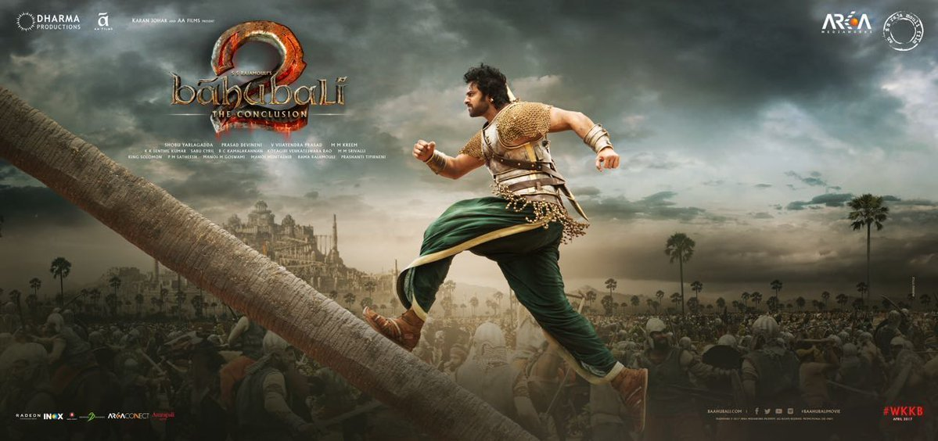

**“BURNING THE MIDNIGHT OIL” BRRIP 7.1 Channel – EP3 1280P (Please Seed and Enjoy)**

**We are curious as to how the whole process is taken up, and I’m sure if there is one part of this discussion that our readers would be waiting for is to know how do you describe the whole procedure from getting the movie and uploading it?**

**Procurement of Movie – Sources and Reasons – Method One**

*(My interviewee goes into deep thought. There is some kind of conflict that he is battling out in his mind. It’s the look, a look that I often see in people when they know they are excited, or at least ready to speak something, but the sanity of their experience asks them to stop. Most people do stop and never utter a word. Some overcome their fear and speak up. Bhaskar belongs to the latter. He really needs his revenge. It is clear that he is hurt, not just because of the reasons he stated above, but I can sense there is something more personal. Nevertheless, he does speak up)*

For example, let’s say there is a movie, *Bhagavan*. Assume that, a superstar is acting in it, and it is made with a big budget, of say 70 crores. Why I am saying big budget is that there is a procedure for different types of movies and different production values. So let’s say *Bhagavan* is a big budget movie, with so much pressure on it to perform. Today, as a producer, if you can make half your budget back in the first three days, you are successful, because the remaining you can make in remaining time, satellite versions, and YouTube channels. So, *Bhagavan* is fully prepared.

First, what does the producer do? Let’s say I’m the producer, ok? So first I will call a press and insider premiere, in a closed preview theatre. Most of such preview theatres are in film studios and have a capacity of not more than 50 people. The movie in its unedited format, just after CBFC certificate is shown, with watermarks and stuff. That’s where TamilRockers come in. If you are someone related to TamilRockers, you will go and talk to the organizers and film studio staff. Pay close to 70k or 1lakh to get the preview print. You take the print, rip it, and save it for yourself. Just before the release date, you just make that money back, by showing a small clip to the producer. Say you can ask him, 3 lakhs to not upload the movie online. The loss is too much for him, he thinks, and pays automatically. You get a margin of 2 lakhs, of which again 30% will go to the organizer, who will claim that their system was hacked or put the blame on some peon or worker.  That is one way of getting business.

If the producer doesn’t pay, I can still make my 3 lakhs from torrent host sites, who jump to take my print. I send them the clip too. They know it’s a huge budget movie. Imagine the number of Ads and Downloads they will get. So, they are more than happy to pay 3 lakhs (even more) to get the movie. You get the margin and the same procedure as above. Once, we have the movie, it’s easy to do other parts of the business. Getting the movie is the most difficult task. Buying Preview copy from preview theatres is one way.

Sometimes, it also happens, that some movie producers, when they get a feedback that the movie is not very good, approach us to release a small clip onto online, either torrent or YouTube. It is very rare, but it did happen a couple of years back with a blockbuster Telugu movie. Initially, preview people were bored of it, but when we released an hour of the movie, through torrents, people became interested and made it a hit when it released a week later. These days, instead of movies, we are *asked* to release trailers beforehand to see how the response is. If it is good, then fine. If it is not good, they will change it and rerelease. You see, everything is very fragile. If someone gets an impression that the film is bad, because of the trailer, gone, the movie is gone.

**Procurement of Movie – Sources and Reasons – Method Two**

The second method of getting a movie before release, or on release, or a few hours later is W.F.D. Worldwide Film Distribution technology. So let’s continue with the movie *Bhagavan,* what is the easiest way for me as a producer to make money back quickly. Simple I have to screen it overseas. Why overseas? Theatre and Slot rentals are cheaper, and the margin you make in USD, Dirham or Euro is higher. Since there are hundreds and thousands of screens abroad, you can easily fixate on at least a 100 shows abroad. So, yeah, as a Producer I want to reach a maximum number of people na? That’s where I approach, Worldwide Film Distribution technology. All the major multiplexes use this technology, where they just have to stream the movie. Means, your movie is uploaded in their secure server, spread across three to four different servers, and they give the multiplex people links of each part, as and when required. The whole movie, depending on 2D or 3D, is divided into 4 or 2 parts, and stored on different servers. They are secure systems, and you can’t touch them. But the links have to come to theatres right? That’s where we come in.

So it is simple. You get a deal with a theatre, registered with W.F.D, and when the streaming link arrives (usually just 15 minutes before the first show), you ‘double route’ it. The double route is a technique where you can register as two screens showing the same movie at the same time, or at a difference of ten minutes maximum. So, then W.F.D sends across participation key,  we can login for the link as well. Of course, there is no other screen, it is just playing into our system. Some theatres help us, because it’s easier to make money from us. We pay them around 4 to 10 lakh for those links. That is his additional income over and above the screening money, which he has to record and pay tax on. Calling up the producer is common here also.

That was a flaw W.F.D was having last year, but now after complaints, it has changed the login system and streaming credentials.

Another easier way to get your print is when you have people in Dubai, Bahrain, Canada or China. Because of Movie regulation there, W.F.D has to send the whole movie at least 2 hours before. And since the Exhibitors union has to record how the movie is performing, all the links are forwarded to local film committee’s way before the release. A leak always happens.

**Procurement of Movie – Sources and Reasons – Method Three**

Another way of getting Camrips, and Firstday rips, is through contributors. It’s simple. TamilRockers pays 500 to 1500 for each movie. Kids go and record movies in theatres send us the sample, and after payment, they send us the movie. The better the print, the better the pay. Recently, we have a few graphic designers for editing, brightening, and scaling the prints. They edit it and put up. It’s a simple process. Prints from projection rooms, mobiles, tablets etc, mostly come from B town theatres where usually, second show movies or Benefit show movies are played at 4 am in the morning. They are still showreel based theatres, so the print is ok only. There is no master print, but who cares. People, fans, curious people still download them and watch them. And latest movie always sells.



**Chapter Four: Conversations with Tamil Rockers – The Repercussions and the Philosophy of Crime**

**When you say all this, it seems to me that you are a widespread network. Then how is it possible for you guys to stay under the radar for so long? Also, how do you make money out of movie torrents? Is it hit based or download based?**

I am talking to you, so I think we are coming out of radar. And I personally also, want to bring out TamilRockers. We are a good network. Our office is only one, in Nungambakkam, even now. But we have contributors and distributors all over the world. I’ll tell you something. Our biggest contributors come from US, who send us movies like Vivegam first day, with the help of W.F.D hackers. Easy money no? They will come. And if there are individual uploaders in KAT or PirateBay, we buy them off. Also, for HD prints, we have screenrips from NetFlix, Eros Now, Hulu etc. So it is a good business.

Between the two of us, the producers are afraid of exposing us. Let’s say I’m a rival producer, and you are producing a movie. I will pay TamilRockers to leak the movie beforehand on the first day. Take the case of Uthama Villain. We had the print out after 3 hours of release. HD print that is also. We were paid to do so. Huge payments come across for that. Lakhs of rupees. Even recently, a Telugu producer approached us to leak another movie, so that his movie can perform well. You see, those two movies had the same release date. So it all happens. When you are part of the crime, how can you expose the criminals?

Regarding money, apart from the above ways of doing so, we have a different revenue way online. So, basically, we upload the sample of the print we have to the torrent host. They contact us back, giving us a separate portal and account to upload. The more hits we get to our account, the more we appear in search. The ad revenue is distributed in 45% to us, and 55% of them. Some sites like KAT, ISOHunt, DesiTorrents, Torrentz pay us for the print as well. There is a bid. How we do that, I can’t tell you on record. But there are ways, and we get paid for the prints we have. And it also depends on the movie name being searched on the torrent sites. These are recorded and the demand arises. Demand and Supply is the answer.

**Lastly, Do you don’t think you are doing something wrong? Your business, or at least the idea of business, don’t you feel is ruining the other business of movie production? Because of Piracy, movies get hefty losses every year?**

So don’t download movies from Torrents. Simple. And we are gone. Simple question, how do you watch this Game of Thrones episodes? Don’t tell me that 3 million people in India watch Game Of Thrones on Star Plus.

(Star World, I say, compelled to correct him irrelevantly)

Huh. Yes. Star World. Will you wait? No, no, you will download, put out the status, do discussions etc. Tell me how that is correct, and what we do is wrong? As I said, you search for movies, and we give you those. Why? Don’t judge us. Your all movie discussions would not happen if we didn’t bring out movies across the world to your system in torrents. Netflix and Amazon Prime came now, but who wants to buy a subscription right? You are as it is paying 500 for internet every month. Why are ISPs giving you 100 GB free data? To just watch legal videos or porn? No no, for you to download torrents.

If I sit on your side, I can also say many things about legal, morals, ethics etc. But tell me the truth, can any movie enthusiast live without torrents today? Why? Reasons are, you need to spend 500 to 1000 every time you go watch a movie. If it’s a family, it comes to 2000 in Gemini Multiplex or Casino Movies. Movie watching is becoming a rich people’s luxury. No one questions that? Even if you make utter bullshit, we have to go watch ah? Which is a bigger crime? The only way is making a movie like Bahubali or Enthiran, which you want to watch in theatre for the experience. But others, who cares? Every producer wants to release the movie in Multiplex because the margin is good. As soon as they do it, who will watch? I personally cannot even buy the tickets, let alone popcorn, snacks, parking tickets. Why is Popcorn 200 rupees? No one questions that? So anyway, we exist because we are needed. And I am not just saying about Tamil Rockers. But everyone in this illegal business of torrents and piracy.



**Chapter Four: Conversations with Tamil Rockers – Off the Record**

As the interview came to an end, Bhaskar pleaded with me, that he wanted to share something off the record. These were things which implicated multiple production houses, streaming partners, and the nexus of film distributors. Every single one of these elements had some part to play in the widespread contagion of Piracy. TamilRockers were, as per the information, just the tip of the iceberg. As my interviewee said, Demand and Supply was always the key. Torrents were just the perfect bridge to match the two economic standpoints. The bigger the movie gets, the riskier it gets. The feverish anticipation, backfire as people of meagre means, what their passion for a hero, movie, caste, or region rewarded. “I’ve watched the movie first day” means something in our part of the world, doesn’t it? A misplaced bravado and achievement come up. To watch it, post it on Facebook, create Memes, trolls, anything and everything. We are partners in this, don’t you think?

Piracy is illegal. And so is watching pirated movies or downloading pirated/cracked software. Where does it end? We leave it to the reader to decide.

On August 29th, Bhaskar presented to us, vital and essential information about the torrent site, TamilRockers, who he previously had a fall out for. Despite the personal reasons, Bhaskar’s evidence has been submitted by us to the respective Cybercrime divisions. Upon perusal by the officials, most of the evidence provided had been found as legitimate, and action worthy.

On September 10th, a coordinated scheme of luring admins of torrents site, TamilRockers to Coimbatore was orchestrated with the help of Bhaskar. Unfortunately, only one another admin turned up at Coimbatore. On September 12th, this admin was arrested on the charges of illegal production and distribution of unauthorized movie content under Indian Copyright (Protection) Act, 1957 as amended to include online piracy by 2012.

*(The main head, behind TamilRockers establishment, Daniel Raju has since absconded. Bhaskar presently has been the prime informant on the nexus of piracy and shall remain to be in police protection for the foreseeable future. The story of Daniel Raju, his rise from a humble ice cream seller, to establishing the biggest movie piracy ring in India, is a story for another time).*

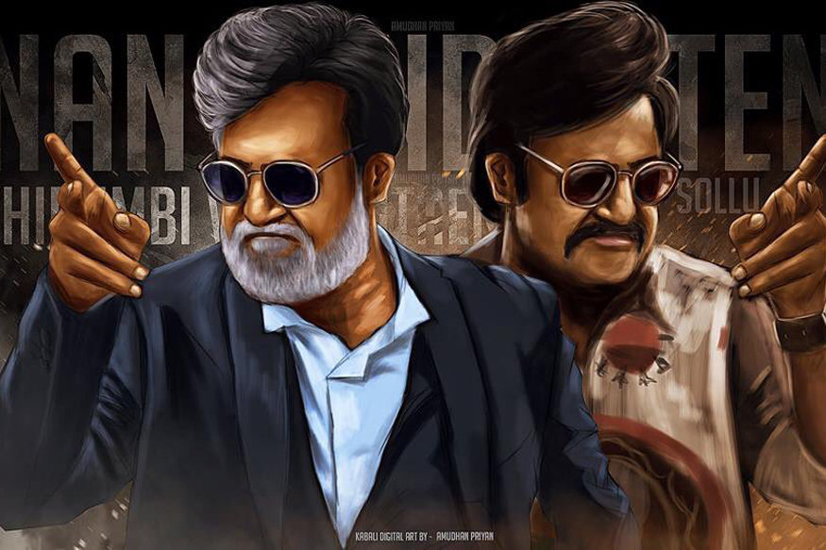

**Facts of Torrents and Piracy from Indian Piracy Landscape Study**

1. Indians are the fourth largest English movie torrents download group, constituting a share of 6.5% of all the downloaders. Also, India has the highest level of Broadband Piracy relative to the Broadband users. (Simply FUP theft)

2. The highest downloads for an Indian movie were Bahubali (1.72 Million), Theri (1.67 Million), Dilwale (1.33 Million), Sultan (1.27 Million), Enthiran (1.22 Million), Kabali (1.16 Million), Raaes (1.11 Million), Dangal (1.09 Million), and Two States (1 Million) to round off.

3. India stands fourth in accessing piracy movie sites for streaming purposes. A study of 2015 found that Indians constitute 18% of the total population who stream the movie online on illegal upload sites.

4. Students from Technology Colleges (BTech Colleges) constitute 37.08% (the largest portion) of the total users downloading movies through torrents in India for the period 2015/16.

5. The most downloaded English TV Show torrents in unsurprisingly Game Of Thrones with a huge 37.2% of total TV show downloads in India constituting it. It is followed, more noticeably by Friends (10.6%), How I Met Your Mother (7.8%), Two And A Half Men (6.5%), and Narcos (3.3%).

6. One solution for this, was worldwide DTH release, alongside theatres. In 2013, Kamal Hassan’s Viswaroopam was touted to release in DTH formats, on the same day as the theatres to avoid piracy. The distributors and producers brought a case against Kamal Hassan and stopped him from doing that. This procedure could have been something worth a try to avoid piracy.

7. Viewing, downloading, exhibiting or duplicating an illicit copy of the contents is punishable as an offence under the laws of India, including but not limited to under Sections 63, 63-A, 65 and 65-A of the Copyright Act, 1957 which prescribe imprisonment for 3 years and also fine of up to Rs. 3,00,000/-.